**Student Marksheet Analyzer**

1. Objective

The objective of this task is to build a Student Marksheet Analyzer using Python. This analyzer reads student marks from a CSV file, calculates total and average marks, evaluates pass/fail status, identifies the top performer, and provides subject-wise performance insights.

2. Tools & Technologies Used

| Tool | Description |
| --- | --- |
| Python | Programming language for logic and analysis |
| pandas | Python library used for data manipulation and analysis |
| VS Code | Code editor used to write and run the Python program |
| CSV File | Used to store and manage student data |

3. Step-by-Step Implementation

Step 1: Setup Project Folder

Create a folder named: student_marksheet_project

Inside it, create two files:

marksheet_analyzer.py (Python file)

marks.csv (CSV file with student marks)

Step 2: Prepare the CSV File

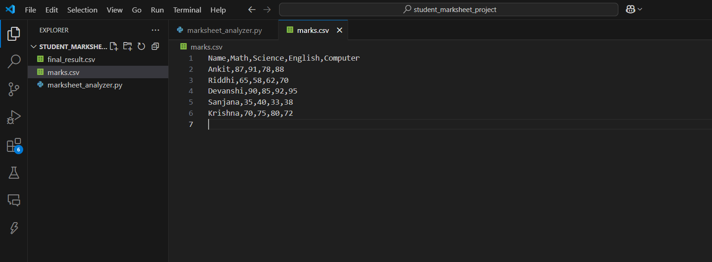

Step 3: Install Required Library

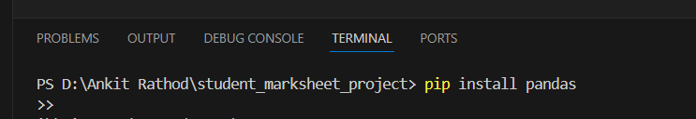

This installs the pandas library which is essential for handling tabular data.

Step 4: Write Python Code

Paste the following code into marksheet_analyzer.py:

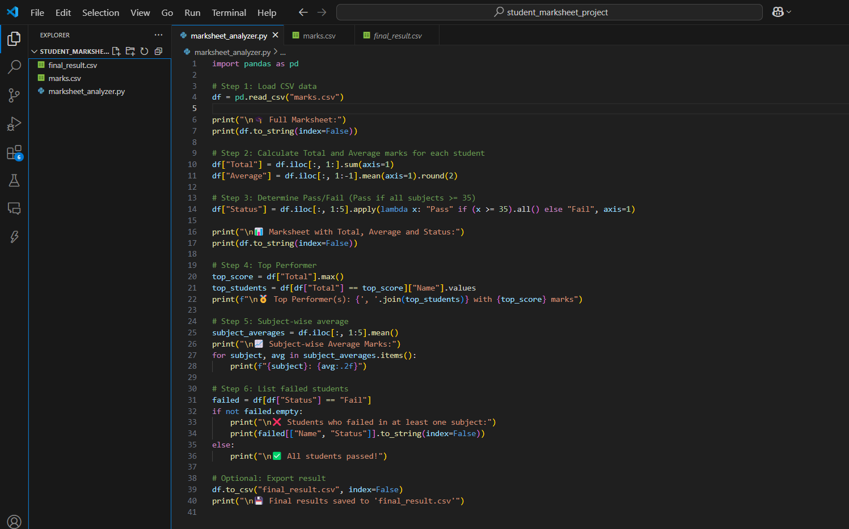

Step 5: Run the Program

Open VS Code

Use Terminal and navigate to your folder:

cd path/to/student_marksheet_project

Step 6: Output

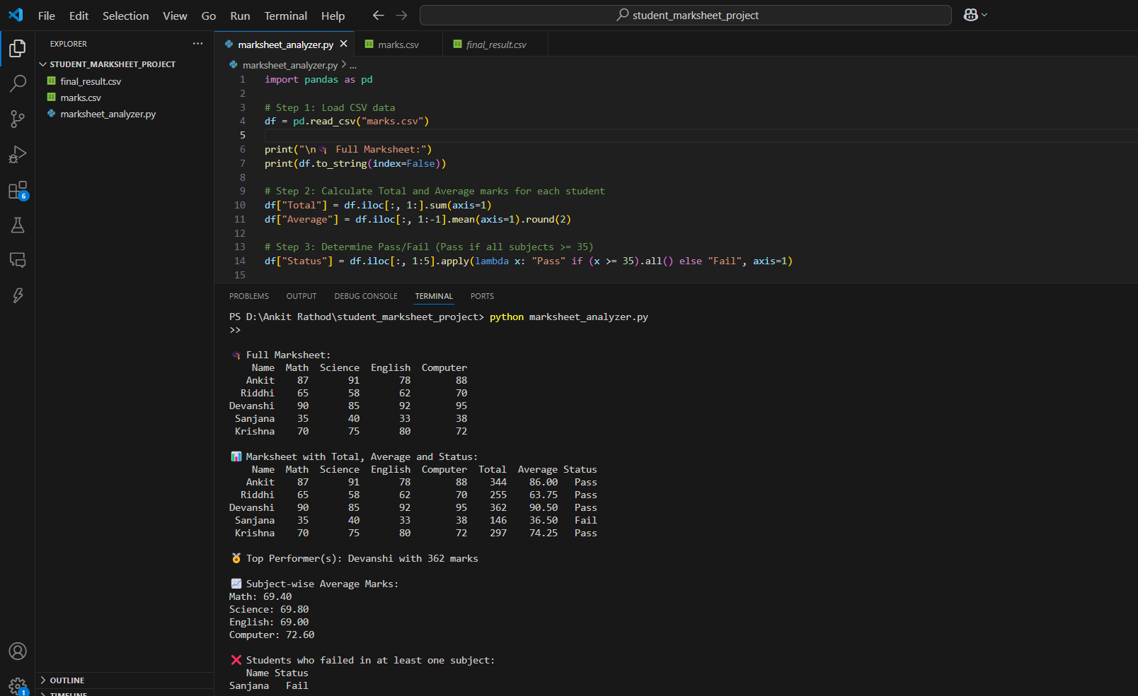

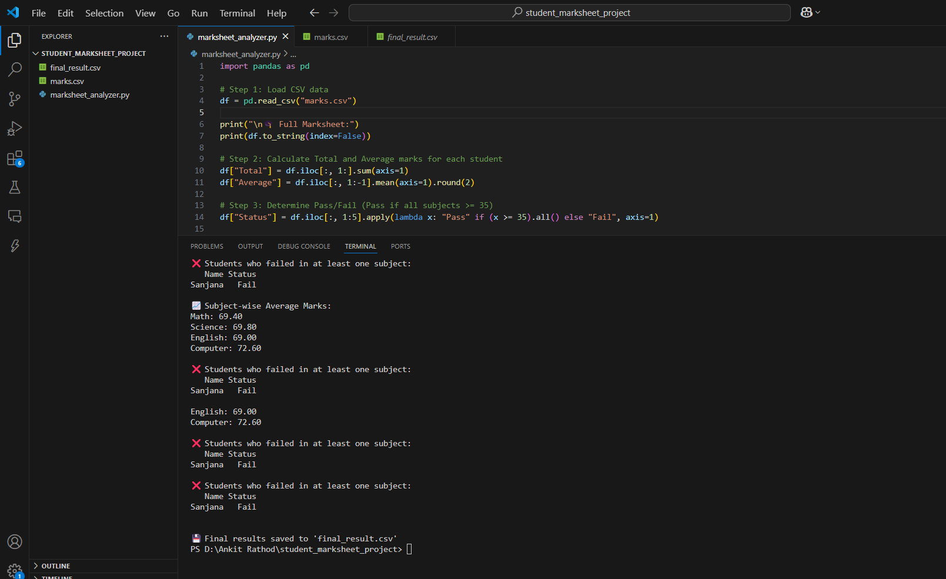

4. Conclusion

This task successfully demonstrated how Python and pandas can be used to analyze academic data from a CSV file. The project highlights key skills in:

* Data processing
* Conditional logic
* Basic reporting
* File operations